POLICY AND DOCUMENT
CLIENT REFERENCE:
URL : https://web2ess.elitehrms.com
UserName : DC0003
Password : M@ster
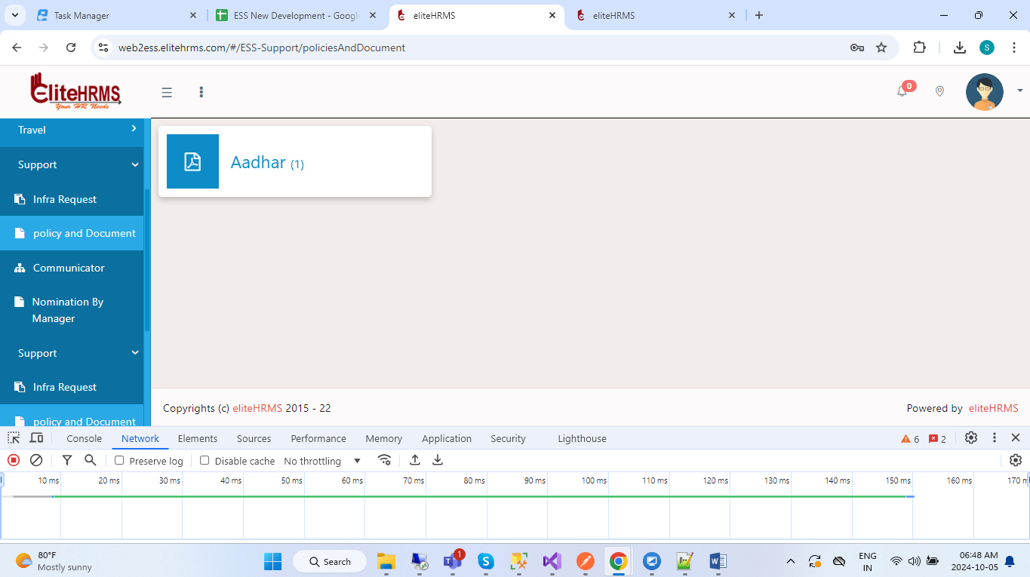
1.Only one get api to call “GetPoliciesAndDocuments”.
https://localhost:44349/api/Support/GetPoliciesAndDocuments
{
"Response": {
"_status": "Success",
"_code": "111",
"_Source": "GetPoliciesAndDocuments",
"_Description": "",
"_Details": "",
"_TransID": null,
"_Timestamp": "20241005052626"
},
"PoliciesAndDocuments": [
{
"DocumentName": "rt",
"DocumentType": "Address Proof",
"DocumentAttachment": "https://FIBO.elitehrms.com/Upload/Attachment/Global DropDown -Updated.xlsx"
},
{
"DocumentName": "Employee Handbook",
"DocumentType": "Offer Letter",
"DocumentAttachment": "https://FIBO.elitehrms.com/Upload/Attachment/"
}
]
}

